

**DEPARTMENT OF SOFTWARE AND SYSTEMS ENGINEERING**

***S****chool of* ***I****nformation* ***T****echnology and* ***E****ngineering*

**SCM PROJECT**

**TOPIC**

**Events Management System**

**Nirmal Kumar (13MSE0066)**

**Pream Kumar (13MSE0198)**

**1. Introduction**

**1.1 Abstract**

In VIT university one of the most common problems that clubs and chapters face is managing their events. Organising an event includes registering the participating members, booking the required rooms, expenditure calculations, managing time and advertising the event and many more related operations. What we aim to do is create an online event management system project that serves all the registered users to login and new users would have to register new into the system. Users can select from a list of event types. Once the user enters an event type the system then allows the user to select date, time and also register feedback of the event. We have basically two interfaces one for the event manager and the other for the students registering for the event. All data regarding the event or the student participating is stored in the database. This makes it easier to manage data. Our main aim is to simplify the work of event managers and the participating students. We hope that our product accomplishes that and provides all required assistance to the clubs and chapters of VIT university.

**1.2 Problem Statement**

The clubs and chapters of VIT face a huge problem when it comes to managing events. All the processes are done manually from registering for events to advertising them. Our application aims to solve all these problems and provide a user-friendly interface which can be used by event managers and students.

**2. Overview and planning**

**2.1 Proposed system overview**

Our proposed system aims to solve all the problems of the existing system. Our application provides up-to-date status and accurate data regarding each event to all the students involved. Using our application students can easily browse through events taking place and also register for them on the spot. Students are made more aware of the upcoming events and it also serves as platform in which the event organizers advertise their events. Students will also be notified if there are changes to the destination and time of the event taking place. This helps students to easily participate in the event without confusion. We have basically two interfaces one for the event manager and the other for the students registering for the event. All data regarding the event or the student participating is stored in the database. This makes it easier to manage data. Our main aim is to simplify the work of event managers and the participating students.

**2.2 Hardware Requirements**

*Will work on any basic System

**2.3 Software Requirements**

Operating System – Windows 7 or Higher

**3. Literature Survey**

[1] Scheduler Application

This is an android application that acts as a channel for students and faculties to help, communicate, share, authenticate, participate in events, register for events and get updates about events. This system implements a user verification system which authenticates users. User forums built in the application facilitates group discussions and sharing of ideas. The application also serves as a reminder for upcoming registered events. The main idea and purpose for building this application is to connect several users in order to help them managing schedules and events.

[2] Event Management an Android Application

Planning a successful event is quite difficult keeping in mind all the difficulties it faces. This application is designed keeping in mind all these difficulties and complexities. Events as you know play a very important role in our society. Often people involved lack the expertise and time to plan events themselves. In order to manage such issues this app has been created. It is easy to use and has a user-friendly interface. The modules involved are the logging and authentication module, an event creating module, a location tracking module, a budget estimation module and a feedback module.

[3] Android application for event management and information propagation

Advertising an event or in other words making people aware of your event is a difficult task. This project intends to solve the problems of propagating information and news. The traditional event management systems have a lot of disadvantages such as heavy paperwork and long registration queues. This project aims to solve the problems of the traditional event management systems. This application will enable users to manage their event participation, such as reserving seats and on spot event registrations. This application also implements the use of QR code to provide a simple way to verify participant’s identity in an event.

**4. System Design**

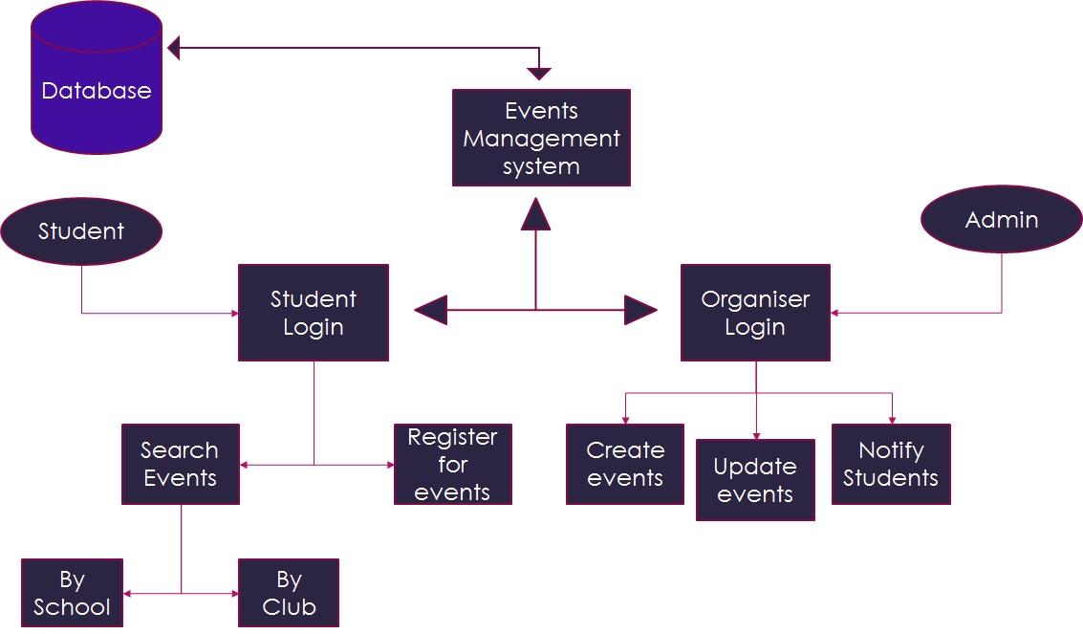

**5. System Implementation**

**Code:**

import java.util.Calendar;

import java.util.GregorianCalendar;

import javax.swing.JOptionPane;

/*

* To change this license header, choose License Headers in Project Properties.

* To change this template file, choose Tools | Templates

* and open the template in the editor.

*/

/**

*

* @author Nirmal

*/

public class club1 extends javax.swing.JFrame {

String m,n,pss;

/**

* Creates new form club1

*/

public club1() {

initComponents();

CurrentDate();

}

public void CurrentDate()

{

Calendar cal=new GregorianCalendar();

int month=cal.get(Calendar.MONTH);

int year=cal.get(Calendar.YEAR);

int day=cal.get(Calendar.DAY_OF_MONTH);

date_txt.setText("DATE "+year+"/"+(month+1)+"/"+day);

int second=cal.get(Calendar.SECOND);

int minute=cal.get(Calendar.MINUTE);

int hour=cal.get(Calendar.HOUR);

time_txt.setText("TIME "+hour+":"+(minute)+":"+second);

}

/**

* This method is called from within the constructor to initialize the form.

* WARNING: Do NOT modify this code. The content of this method is always

* regenerated by the Form Editor.

*/

@SuppressWarnings("unchecked")

// <editor-fold defaultstate="collapsed" desc="Generated Code">//GEN-BEGIN:initComponents

private void initComponents() {

club_id = new javax.swing.JLabel();

pass = new javax.swing.JLabel();

t = new javax.swing.JTextField();

p = new javax.swing.JPasswordField();

login = new javax.swing.JButton();

jLabel2 = new javax.swing.JLabel();

date_txt = new javax.swing.JLabel();

time_txt = new javax.swing.JLabel();

jButton1 = new javax.swing.JButton();

jButton2 = new javax.swing.JButton();

jLabel1 = new javax.swing.JLabel();

jLabel3 = new javax.swing.JLabel();

setDefaultCloseOperation(javax.swing.WindowConstants.EXIT_ON_CLOSE);

getContentPane().setLayout(null);

club_id.setFont(new java.awt.Font("Times New Roman", 0, 18)); // NOI18N

club_id.setText("CLUB ID:");

getContentPane().add(club_id);

club_id.setBounds(480, 320, 90, 30);

pass.setFont(new java.awt.Font("Times New Roman", 0, 18)); // NOI18N

pass.setText("PASSWORD:");

getContentPane().add(pass);

pass.setBounds(470, 390, 110, 30);

t.addActionListener(new java.awt.event.ActionListener() {

public void actionPerformed(java.awt.event.ActionEvent evt) {

tActionPerformed(evt);

}

});

getContentPane().add(t);

t.setBounds(600, 320, 230, 30);

p.addActionListener(new java.awt.event.ActionListener() {

public void actionPerformed(java.awt.event.ActionEvent evt) {

pActionPerformed(evt);

}

});

getContentPane().add(p);

p.setBounds(600, 390, 230, 30);

login.setBackground(new java.awt.Color(255, 255, 255));

login.setFont(new java.awt.Font("Times New Roman", 0, 18)); // NOI18N

login.setText("Login");

login.setBorder(javax.swing.BorderFactory.createLineBorder(new java.awt.Color(0, 0, 0)));

login.addActionListener(new java.awt.event.ActionListener() {

public void actionPerformed(java.awt.event.ActionEvent evt) {

loginActionPerformed(evt);

}

});

getContentPane().add(login);

login.setBounds(600, 460, 100, 30);

jLabel2.setIcon(new javax.swing.ImageIcon(getClass().getResource("/first/image/NEW ONE.1.jpg"))); // NOI18N

getContentPane().add(jLabel2);

jLabel2.setBounds(100, 0, 1105, 150);

date_txt.setFont(new java.awt.Font("Goudy Old Style", 0, 24)); // NOI18N

date_txt.setForeground(new java.awt.Color(0, 0, 255));

date_txt.setText("DATE");

getContentPane().add(date_txt);

date_txt.setBounds(1020, 150, 190, 40);

time_txt.setFont(new java.awt.Font("Goudy Old Style", 0, 24)); // NOI18N

time_txt.setForeground(new java.awt.Color(0, 0, 255));

time_txt.setText("TIME");

getContentPane().add(time_txt);

time_txt.setBounds(1020, 190, 200, 50);

jButton1.setBackground(new java.awt.Color(255, 255, 255));

jButton1.setFont(new java.awt.Font("Times New Roman", 0, 18)); // NOI18N

jButton1.setText("Reset");

jButton1.setBorder(javax.swing.BorderFactory.createLineBorder(new java.awt.Color(0, 0, 0)));

jButton1.addActionListener(new java.awt.event.ActionListener() {

public void actionPerformed(java.awt.event.ActionEvent evt) {

jButton1ActionPerformed(evt);

}

});

getContentPane().add(jButton1);

jButton1.setBounds(720, 460, 110, 30);

jButton2.setBackground(new java.awt.Color(255, 255, 255));

jButton2.setFont(new java.awt.Font("Times New Roman", 0, 18)); // NOI18N

jButton2.setText("Back");

jButton2.setBorder(javax.swing.BorderFactory.createLineBorder(new java.awt.Color(0, 0, 0)));

jButton2.addActionListener(new java.awt.event.ActionListener() {

public void actionPerformed(java.awt.event.ActionEvent evt) {

jButton2ActionPerformed(evt);

}

});

getContentPane().add(jButton2);

jButton2.setBounds(660, 520, 100, 30);

jLabel1.setFont(new java.awt.Font("Georgia", 1, 18)); // NOI18N

jLabel1.setForeground(new java.awt.Color(102, 0, 0));

jLabel1.setText(" CLUB LOGIN:");

jLabel1.setBorder(javax.swing.BorderFactory.createLineBorder(new java.awt.Color(0, 0, 0)));

getContentPane().add(jLabel1);

jLabel1.setBounds(440, 230, 150, 50);

jLabel3.setBackground(new java.awt.Color(204, 204, 204));

jLabel3.setForeground(new java.awt.Color(255, 255, 255));

jLabel3.setIcon(new javax.swing.ImageIcon(getClass().getResource("/first/image/waves_of_emotion-1920x1080.jpg"))); // NOI18N

getContentPane().add(jLabel3);

jLabel3.setBounds(-100, -120, 1800, 1320);

setBounds(0, 0, 1736, 724);

}// </editor-fold>//GEN-END:initComponents

private void loginActionPerformed(java.awt.event.ActionEvent evt) {//GEN-FIRST:event_loginActionPerformed

m=t.getText();

n=p.getText();

SQL d=new SQL("jdbc:oracle:thin:@localhost:1521:XE","oracle.jdbc.OracleDriver","system","7200711397");

String str="select password from club where club_id='"+m+"' ";

try{

d.executeQuery(str);

d.rs.next();

pss= d.rs.getString("password");

if(n.equals(pss))

{

this.setVisible(false);

club2 st=new club2();

st.setVisible(true);

st.pack();

}

else

{

JOptionPane.showMessageDialog(null,"Incorrect Login");

//t.requestFocus();

}

}

catch(Exception e)

{

}

}//GEN-LAST:event_loginActionPerformed

private void pActionPerformed(java.awt.event.ActionEvent evt) {//GEN-FIRST:event_pActionPerformed

// TODO add your handling code here:

}//GEN-LAST:event_pActionPerformed

private void tActionPerformed(java.awt.event.ActionEvent evt) {//GEN-FIRST:event_tActionPerformed

// TODO add your handling code here:

//jTextField.requestFocus();

}//GEN-LAST:event_tActionPerformed

private void jButton1ActionPerformed(java.awt.event.ActionEvent evt) {//GEN-FIRST:event_jButton1ActionPerformed

t.setText("");

p.setText("");

// TODO add your handling code here:

}//GEN-LAST:event_jButton1ActionPerformed

private void jButton2ActionPerformed(java.awt.event.ActionEvent evt) {//GEN-FIRST:event_jButton2ActionPerformed

VIT_EVENTS ev=new VIT_EVENTS();

ev.setVisible(true);

this.setVisible(false);

// TODO add your handling code here:

}//GEN-LAST:event_jButton2ActionPerformed

/**

* @param args the command line arguments

*/

public static void main(String args[]) {

/* Set the Nimbus look and feel */

//<editor-fold defaultstate="collapsed" desc=" Look and feel setting code (optional) ">

/* If Nimbus (introduced in Java SE 6) is not available, stay with the default look and feel.

* For details see http://download.oracle.com/javase/tutorial/uiswing/lookandfeel/plaf.html

*/

try {

for (javax.swing.UIManager.LookAndFeelInfo info : javax.swing.UIManager.getInstalledLookAndFeels()) {

if ("Nimbus".equals(info.getName())) {

javax.swing.UIManager.setLookAndFeel(info.getClassName());

break;

}

}

} catch (ClassNotFoundException ex) {

java.util.logging.Logger.getLogger(club1.class.getName()).log(java.util.logging.Level.SEVERE, null, ex);

} catch (InstantiationException ex) {

java.util.logging.Logger.getLogger(club1.class.getName()).log(java.util.logging.Level.SEVERE, null, ex);

} catch (IllegalAccessException ex) {

java.util.logging.Logger.getLogger(club1.class.getName()).log(java.util.logging.Level.SEVERE, null, ex);

} catch (javax.swing.UnsupportedLookAndFeelException ex) {

java.util.logging.Logger.getLogger(club1.class.getName()).log(java.util.logging.Level.SEVERE, null, ex);

}

//</editor-fold>

/* Create and display the form */

java.awt.EventQueue.invokeLater(new Runnable() {

public void run() {

new club1().setVisible(true);

}

});

}

// Variables declaration - do not modify//GEN-BEGIN:variables

private javax.swing.JLabel club_id;

private javax.swing.JLabel date_txt;

private javax.swing.JButton jButton1;

private javax.swing.JButton jButton2;

private javax.swing.JLabel jLabel1;

private javax.swing.JLabel jLabel2;

private javax.swing.JLabel jLabel3;

private javax.swing.JButton login;

private javax.swing.JPasswordField p;

private javax.swing.JLabel pass;

private javax.swing.JTextField t;

private javax.swing.JLabel time_txt;

// End of variables declaration//GEN-END:variables

}

import java.util.Calendar;

import java.util.GregorianCalendar;

import javax.swing.JOptionPane;

/*

* To change this license header, choose License Headers in Project Properties.

* To change this template file, choose Tools | Templates

* and open the template in the editor.

*/

/**

*

* @author Nirmal

*/

public class club2 extends javax.swing.JFrame {

/**

* Creates new form club2

*/

String q,s,s1,s2,s3,s4;

public club2() {

initComponents();

CurrentDate();

}

public void CurrentDate()

{

Calendar cal=new GregorianCalendar();

int month=cal.get(Calendar.MONTH);

int year=cal.get(Calendar.YEAR);

int day=cal.get(Calendar.DAY_OF_MONTH);

date_txt.setText("DATE "+year+"/"+(month+1)+"/"+day);

int second=cal.get(Calendar.SECOND);

int minute=cal.get(Calendar.MINUTE);

int hour=cal.get(Calendar.HOUR);

time_txt.setText("TIME "+hour+":"+(minute)+":"+second);

}

/**

* This method is called from within the constructor to initialize the form.

* WARNING: Do NOT modify this code. The content of this method is always

* regenerated by the Form Editor.

*/

@SuppressWarnings("unchecked")

// <editor-fold defaultstate="collapsed" desc="Generated Code">//GEN-BEGIN:initComponents

private void initComponents() {

jLabel1 = new javax.swing.JLabel();

e = new javax.swing.JTextField();

jLabel2 = new javax.swing.JLabel();

jButton1 = new javax.swing.JButton();

jButton2 = new javax.swing.JButton();

date_txt = new javax.swing.JLabel();

time_txt = new javax.swing.JLabel();

jLabel3 = new javax.swing.JLabel();

jLabel5 = new javax.swing.JLabel();

jLabel6 = new javax.swing.JLabel();

jLabel7 = new javax.swing.JLabel();

l3 = new javax.swing.JLabel();

l1 = new javax.swing.JLabel();

l4 = new javax.swing.JLabel();

l5 = new javax.swing.JLabel();

search = new javax.swing.JButton();

jButton3 = new javax.swing.JButton();

jLabel4 = new javax.swing.JLabel();

setDefaultCloseOperation(javax.swing.WindowConstants.EXIT_ON_CLOSE);

getContentPane().setLayout(null);

jLabel1.setFont(new java.awt.Font("Times New Roman", 0, 18)); // NOI18N

jLabel1.setForeground(new java.awt.Color(255, 255, 0));

jLabel1.setText("Search For Events:");

getContentPane().add(jLabel1);

jLabel1.setBounds(0, 160, 140, 30);

e.setFont(new java.awt.Font("Times New Roman", 1, 18)); // NOI18N

e.setBorder(javax.swing.BorderFactory.createLineBorder(new java.awt.Color(0, 102, 102)));

e.addActionListener(new java.awt.event.ActionListener() {

public void actionPerformed(java.awt.event.ActionEvent evt) {

eActionPerformed(evt);

}

});

getContentPane().add(e);

e.setBounds(150, 160, 150, 30);

jLabel2.setIcon(new javax.swing.ImageIcon(getClass().getResource("/first/image/NEW ONE.1.jpg"))); // NOI18N

getContentPane().add(jLabel2);

jLabel2.setBounds(90, 0, 1140, 146);

jButton1.setFont(new java.awt.Font("Times New Roman", 0, 18)); // NOI18N

jButton1.setForeground(new java.awt.Color(153, 0, 0));

jButton1.setText("UPDATE EVENTS");

jButton1.setBorder(javax.swing.BorderFactory.createLineBorder(new java.awt.Color(0, 0, 0)));

jButton1.addActionListener(new java.awt.event.ActionListener() {

public void actionPerformed(java.awt.event.ActionEvent evt) {

jButton1ActionPerformed(evt);

}

});

getContentPane().add(jButton1);

jButton1.setBounds(940, 320, 190, 50);

jButton2.setFont(new java.awt.Font("Times New Roman", 0, 18)); // NOI18N

jButton2.setForeground(new java.awt.Color(153, 0, 0));

jButton2.setText("VIEW EVENTS");

jButton2.setBorder(javax.swing.BorderFactory.createLineBorder(new java.awt.Color(0, 0, 0)));

jButton2.addActionListener(new java.awt.event.ActionListener() {

public void actionPerformed(java.awt.event.ActionEvent evt) {

jButton2ActionPerformed(evt);

}

});

getContentPane().add(jButton2);

jButton2.setBounds(940, 480, 190, 50);

date_txt.setFont(new java.awt.Font("Goudy Old Style", 0, 24)); // NOI18N

date_txt.setText("DATE");

getContentPane().add(date_txt);

date_txt.setBounds(1010, 150, 190, 32);

time_txt.setFont(new java.awt.Font("Goudy Old Style", 0, 24)); // NOI18N

time_txt.setText("TIME");

getContentPane().add(time_txt);

time_txt.setBounds(1010, 200, 200, 40);

jLabel3.setFont(new java.awt.Font("Vani", 1, 18)); // NOI18N

jLabel3.setForeground(new java.awt.Color(0, 0, 255));

jLabel3.setText(" EVENT_ID");

getContentPane().add(jLabel3);

jLabel3.setBounds(40, 320, 130, 40);

jLabel5.setFont(new java.awt.Font("Vani", 1, 18)); // NOI18N

jLabel5.setForeground(new java.awt.Color(0, 0, 255));

jLabel5.setText(" VENUE");

getContentPane().add(jLabel5);

jLabel5.setBounds(230, 320, 110, 40);

jLabel6.setFont(new java.awt.Font("Vani", 1, 18)); // NOI18N

jLabel6.setForeground(new java.awt.Color(0, 0, 255));

jLabel6.setText(" DATE");

getContentPane().add(jLabel6);

jLabel6.setBounds(450, 320, 100, 40);

jLabel7.setFont(new java.awt.Font("Vani", 1, 18)); // NOI18N

jLabel7.setForeground(new java.awt.Color(0, 0, 255));

jLabel7.setText(" TIME");

getContentPane().add(jLabel7);

jLabel7.setBounds(660, 320, 120, 40);

l3.setBackground(new java.awt.Color(255, 255, 255));

l3.setFont(new java.awt.Font("Vani", 1, 18)); // NOI18N

l3.setForeground(new java.awt.Color(255, 255, 255));

l3.setBorder(javax.swing.BorderFactory.createLineBorder(new java.awt.Color(102, 102, 255)));

getContentPane().add(l3);

l3.setBounds(220, 420, 160, 40);

l1.setBackground(new java.awt.Color(255, 255, 255));

l1.setFont(new java.awt.Font("Vani", 1, 18)); // NOI18N

l1.setForeground(new java.awt.Color(255, 255, 255));

l1.setBorder(javax.swing.BorderFactory.createLineBorder(new java.awt.Color(102, 102, 255)));

getContentPane().add(l1);

l1.setBounds(30, 420, 150, 40);

l4.setBackground(new java.awt.Color(255, 255, 255));

l4.setFont(new java.awt.Font("Vani", 1, 18)); // NOI18N

l4.setForeground(new java.awt.Color(255, 255, 255));

l4.setBorder(javax.swing.BorderFactory.createLineBorder(new java.awt.Color(102, 102, 255)));

getContentPane().add(l4);

l4.setBounds(420, 420, 160, 40);

l5.setBackground(new java.awt.Color(255, 255, 255));

l5.setFont(new java.awt.Font("Vani", 1, 18)); // NOI18N

l5.setForeground(new java.awt.Color(255, 255, 255));

l5.setBorder(javax.swing.BorderFactory.createLineBorder(new java.awt.Color(102, 102, 255)));

getContentPane().add(l5);

l5.setBounds(630, 420, 170, 40);

search.setFont(new java.awt.Font("Times New Roman", 1, 15)); // NOI18N

search.setText("Search");

search.setBorder(javax.swing.BorderFactory.createLineBorder(new java.awt.Color(0, 0, 0)));

search.addActionListener(new java.awt.event.ActionListener() {

public void actionPerformed(java.awt.event.ActionEvent evt) {

searchActionPerformed(evt);

}

});

getContentPane().add(search);

search.setBounds(310, 160, 90, 30);

jButton3.setFont(new java.awt.Font("Times New Roman", 0, 15)); // NOI18N

jButton3.setText("BACK");

jButton3.setBorder(javax.swing.BorderFactory.createLineBorder(new java.awt.Color(0, 0, 0)));

jButton3.addActionListener(new java.awt.event.ActionListener() {

public void actionPerformed(java.awt.event.ActionEvent evt) {

jButton3ActionPerformed(evt);

}

});

getContentPane().add(jButton3);

jButton3.setBounds(490, 690, 120, 50);

jLabel4.setIcon(new javax.swing.ImageIcon(getClass().getResource("/first/image/aurora_vista_colors-1920x1200.jpg"))); // NOI18N

jLabel4.setText("jLabel4");

getContentPane().add(jLabel4);

jLabel4.setBounds(0, -170, 1370, 960);

setBounds(0, 0, 1382, 806);

}// </editor-fold>//GEN-END:initComponents

private void eActionPerformed(java.awt.event.ActionEvent evt) {//GEN-FIRST:event_eActionPerformed

// TODO add your handling code here:

}//GEN-LAST:event_eActionPerformed

private void jButton2ActionPerformed(java.awt.event.ActionEvent evt) {//GEN-FIRST:event_jButton2ActionPerformed

this.setVisible(false);

// TODO add your handling code here:

club3_view cb4=new club3_view();

cb4.setVisible(true);

}//GEN-LAST:event_jButton2ActionPerformed

private void jButton1ActionPerformed(java.awt.event.ActionEvent evt) {//GEN-FIRST:event_jButton1ActionPerformed

this.setVisible(false);

club3_update cb3=new club3_update();

cb3.setVisible(true);

// TODO add your handling code here:

}//GEN-LAST:event_jButton1ActionPerformed

private void searchActionPerformed(java.awt.event.ActionEvent evt) {//GEN-FIRST:event_searchActionPerformed

// TODO add your handling code here:

q=(String) e.getText();

if(q.equals(""))

{

JOptionPane.showMessageDialog(null,"Please Enter The Event Name");

}

SQL d=new SQL("jdbc:oracle:thin:@localhost:1521:XE","oracle.jdbc.OracleDriver","system","7200711397");

String str="select ev_id,ev_venue,ev_date,ev_time from ieys where ev_name='"+q+"' ";

try{

d.executeQuery(str);

d.rs.next();

{

int i=d.rs.getInt("ev_id");

s=Integer.toString(i);

s1=d.rs.getString("ev_venue");

s2=d.rs.getString("ev_date");

s3=d.rs.getString("ev_time");

l1.setText(s);

l3.setText(s1);

l4.setText(s2);

l5.setText(s3);

}

}

catch(Exception e)

{

JOptionPane.showMessageDialog(null,"Event Name is Not Correct");

}

}//GEN-LAST:event_searchActionPerformed

private void jButton3ActionPerformed(java.awt.event.ActionEvent evt) {//GEN-FIRST:event_jButton3ActionPerformed

club1 ev=new club1();

ev.setVisible(true);

this.setVisible(false);

// TODO add your handling code here:

}//GEN-LAST:event_jButton3ActionPerformed

/**

* @param args the command line arguments

*/

public static void main(String args[]) {

/* Set the Nimbus look and feel */

//<editor-fold defaultstate="collapsed" desc=" Look and feel setting code (optional) ">

/* If Nimbus (introduced in Java SE 6) is not available, stay with the default look and feel.

* For details see http://download.oracle.com/javase/tutorial/uiswing/lookandfeel/plaf.html

*/

try {

for (javax.swing.UIManager.LookAndFeelInfo info : javax.swing.UIManager.getInstalledLookAndFeels()) {

if ("Nimbus".equals(info.getName())) {

javax.swing.UIManager.setLookAndFeel(info.getClassName());

break;

}

}

} catch (ClassNotFoundException ex) {

java.util.logging.Logger.getLogger(club2.class.getName()).log(java.util.logging.Level.SEVERE, null, ex);

} catch (InstantiationException ex) {

java.util.logging.Logger.getLogger(club2.class.getName()).log(java.util.logging.Level.SEVERE, null, ex);

} catch (IllegalAccessException ex) {

java.util.logging.Logger.getLogger(club2.class.getName()).log(java.util.logging.Level.SEVERE, null, ex);

} catch (javax.swing.UnsupportedLookAndFeelException ex) {

java.util.logging.Logger.getLogger(club2.class.getName()).log(java.util.logging.Level.SEVERE, null, ex);

}

//</editor-fold>

/* Create and display the form */

java.awt.EventQueue.invokeLater(new Runnable() {

public void run() {

new club2().setVisible(true);

}

});

}

// Variables declaration - do not modify//GEN-BEGIN:variables

private javax.swing.JLabel date_txt;

private javax.swing.JTextField e;

private javax.swing.JButton jButton1;

private javax.swing.JButton jButton2;

private javax.swing.JButton jButton3;

private javax.swing.JLabel jLabel1;

private javax.swing.JLabel jLabel2;

private javax.swing.JLabel jLabel3;

private javax.swing.JLabel jLabel4;

private javax.swing.JLabel jLabel5;

private javax.swing.JLabel jLabel6;

private javax.swing.JLabel jLabel7;

private javax.swing.JLabel l1;

private javax.swing.JLabel l3;

private javax.swing.JLabel l4;

private javax.swing.JLabel l5;

private javax.swing.JButton search;

private javax.swing.JLabel time_txt;

// End of variables declaration//GEN-END:variables

}

/*

* To change this license header, choose License Headers in Project Properties.

* To change this template file, choose Tools | Templates

* and open the template in the editor.

*/

/**

*

* @author Nirmal

*/

public class club3_view extends javax.swing.JFrame {

/**

* Creates new form club3_view

*/

public club3_view() {

initComponents();

}

/**

* This method is called from within the constructor to initialize the form.

* WARNING: Do NOT modify this code. The content of this method is always

* regenerated by the Form Editor.

*/

@SuppressWarnings("unchecked")

// <editor-fold defaultstate="collapsed" desc="Generated Code">//GEN-BEGIN:initComponents

private void initComponents() {

setDefaultCloseOperation(javax.swing.WindowConstants.EXIT_ON_CLOSE);

javax.swing.GroupLayout layout = new javax.swing.GroupLayout(getContentPane());

getContentPane().setLayout(layout);

layout.setHorizontalGroup(

layout.createParallelGroup(javax.swing.GroupLayout.Alignment.LEADING)

.addGap(0, 1963, Short.MAX_VALUE)

);

layout.setVerticalGroup(

layout.createParallelGroup(javax.swing.GroupLayout.Alignment.LEADING)

.addGap(0, 1145, Short.MAX_VALUE)

);

setBounds(0, 0, 1979, 1183);

}// </editor-fold>//GEN-END:initComponents

/**

* @param args the command line arguments

*/

public static void main(String args[]) {

/* Set the Nimbus look and feel */

//<editor-fold defaultstate="collapsed" desc=" Look and feel setting code (optional) ">

/* If Nimbus (introduced in Java SE 6) is not available, stay with the default look and feel.

* For details see http://download.oracle.com/javase/tutorial/uiswing/lookandfeel/plaf.html

*/

try {

for (javax.swing.UIManager.LookAndFeelInfo info : javax.swing.UIManager.getInstalledLookAndFeels()) {

if ("Nimbus".equals(info.getName())) {

javax.swing.UIManager.setLookAndFeel(info.getClassName());

break;

}

}

} catch (ClassNotFoundException ex) {

java.util.logging.Logger.getLogger(club3_view.class.getName()).log(java.util.logging.Level.SEVERE, null, ex);

} catch (InstantiationException ex) {

java.util.logging.Logger.getLogger(club3_view.class.getName()).log(java.util.logging.Level.SEVERE, null, ex);

} catch (IllegalAccessException ex) {

java.util.logging.Logger.getLogger(club3_view.class.getName()).log(java.util.logging.Level.SEVERE, null, ex);

} catch (javax.swing.UnsupportedLookAndFeelException ex) {

java.util.logging.Logger.getLogger(club3_view.class.getName()).log(java.util.logging.Level.SEVERE, null, ex);

}

//</editor-fold>

/* Create and display the form */

java.awt.EventQueue.invokeLater(new Runnable() {

public void run() {

new club3_view().setVisible(true);

}

});

}

// Variables declaration - do not modify//GEN-BEGIN:variables

// End of variables declaration//GEN-END:variables

}

import java.util.Calendar;

import java.util.GregorianCalendar;

/*

* To change this license header, choose License Headers in Project Properties.

* To change this template file, choose Tools | Templates

* and open the template in the editor.

*/

/**

*

* @author MAADHI

*/

public class Events1 extends javax.swing.JFrame {

/**

* Creates new form Events1

*/

public Events1() {

initComponents();

CurrentDate();

}

public void CurrentDate()

{

Calendar cal=new GregorianCalendar();

int month=cal.get(Calendar.MONTH);

int year=cal.get(Calendar.YEAR);

int day=cal.get(Calendar.DAY_OF_MONTH);

date_txt.setText("DATE "+year+"/"+(month+1)+"/"+day);

int second=cal.get(Calendar.SECOND);

int minute=cal.get(Calendar.MINUTE);

int hour=cal.get(Calendar.HOUR);

time_txt.setText("TIME "+hour+":"+(minute)+":"+second);

}

/**

* This method is called from within the constructor to initialize the form.

* WARNING: Do NOT modify this code. The content of this method is always

* regenerated by the Form Editor.

*/

@SuppressWarnings("unchecked")

// <editor-fold defaultstate="collapsed" desc="Generated Code">//GEN-BEGIN:initComponents

private void initComponents() {

Faculty_login = new javax.swing.JButton();

Student_login = new javax.swing.JButton();

jLabel2 = new javax.swing.JLabel();

date_txt = new javax.swing.JLabel();

time_txt = new javax.swing.JLabel();

jButton1 = new javax.swing.JButton();

jLabel1 = new javax.swing.JLabel();

setDefaultCloseOperation(javax.swing.WindowConstants.EXIT_ON_CLOSE);

getContentPane().setLayout(null);

Faculty_login.setFont(new java.awt.Font("Times New Roman", 0, 18)); // NOI18N

Faculty_login.setForeground(new java.awt.Color(0, 102, 102));

Faculty_login.setText("FACULTY LOGIN");

Faculty_login.setBorder(javax.swing.BorderFactory.createLineBorder(new java.awt.Color(51, 51, 255)));

Faculty_login.addActionListener(new java.awt.event.ActionListener() {

public void actionPerformed(java.awt.event.ActionEvent evt) {

Faculty_loginActionPerformed(evt);

}

});

getContentPane().add(Faculty_login);

Faculty_login.setBounds(610, 360, 220, 50);

Student_login.setFont(new java.awt.Font("Times New Roman", 0, 18)); // NOI18N

Student_login.setForeground(new java.awt.Color(0, 102, 102));

Student_login.setText("STUDENT LOGIN");

Student_login.setBorder(javax.swing.BorderFactory.createLineBorder(new java.awt.Color(51, 51, 255)));

Student_login.addActionListener(new java.awt.event.ActionListener() {

public void actionPerformed(java.awt.event.ActionEvent evt) {

Student_loginActionPerformed(evt);

}

});

getContentPane().add(Student_login);

Student_login.setBounds(610, 440, 220, 50);

jLabel2.setIcon(new javax.swing.ImageIcon(getClass().getResource("/first/image/NEW ONE.1.jpg"))); // NOI18N

getContentPane().add(jLabel2);

jLabel2.setBounds(150, 0, 1105, 146);

date_txt.setFont(new java.awt.Font("Goudy Old Style", 0, 24)); // NOI18N

date_txt.setForeground(new java.awt.Color(255, 255, 255));

date_txt.setText("DATE");

getContentPane().add(date_txt);

date_txt.setBounds(1040, 150, 210, 40);

time_txt.setFont(new java.awt.Font("Goudy Old Style", 0, 24)); // NOI18N

time_txt.setForeground(new java.awt.Color(255, 255, 255));

time_txt.setText("TIME");

getContentPane().add(time_txt);

time_txt.setBounds(1040, 200, 210, 40);

jButton1.setFont(new java.awt.Font("Times New Roman", 0, 14)); // NOI18N

jButton1.setText("BACK");

jButton1.setBorder(javax.swing.BorderFactory.createLineBorder(new java.awt.Color(102, 0, 0)));

jButton1.addActionListener(new java.awt.event.ActionListener() {

public void actionPerformed(java.awt.event.ActionEvent evt) {

jButton1ActionPerformed(evt);

}

});

getContentPane().add(jButton1);

jButton1.setBounds(150, 150, 90, 30);

jLabel1.setIcon(new javax.swing.ImageIcon(getClass().getResource("/first/image/crystal_light-1920x1080.jpg"))); // NOI18N

jLabel1.setText("jLabel1");

getContentPane().add(jLabel1);

jLabel1.setBounds(-16, 0, 1400, 790);

setBounds(0, 0, 1397, 828);

}// </editor-fold>//GEN-END:initComponents

private void Student_loginActionPerformed(java.awt.event.ActionEvent evt) {//GEN-FIRST:event_Student_loginActionPerformed

// TODO add your handling code here:

student_1 st=new student_1();

st.setVisible(true);

this.setVisible(false);

}//GEN-LAST:event_Student_loginActionPerformed

private void Faculty_loginActionPerformed(java.awt.event.ActionEvent evt) {//GEN-FIRST:event_Faculty_loginActionPerformed

// TODO add your handling code here:

faculty_1 fa=new faculty_1();

fa.setVisible(true);

this.setVisible(false);

}//GEN-LAST:event_Faculty_loginActionPerformed

private void jButton1ActionPerformed(java.awt.event.ActionEvent evt) {//GEN-FIRST:event_jButton1ActionPerformed

this.setVisible(false);

VIT_EVENTS ev=new VIT_EVENTS();

ev.setVisible(true);

// TODO add your handling code here:

}//GEN-LAST:event_jButton1ActionPerformed

/**

* @param args the command line arguments

*/

public static void main(String args[]) {

/* Set the Nimbus look and feel */

//<editor-fold defaultstate="collapsed" desc=" Look and feel setting code (optional) ">

/* If Nimbus (introduced in Java SE 6) is not available, stay with the default look and feel.

* For details see http://download.oracle.com/javase/tutorial/uiswing/lookandfeel/plaf.html

*/

try {

for (javax.swing.UIManager.LookAndFeelInfo info : javax.swing.UIManager.getInstalledLookAndFeels()) {

if ("Nimbus".equals(info.getName())) {

javax.swing.UIManager.setLookAndFeel(info.getClassName());

break;

}

}

} catch (ClassNotFoundException ex) {

java.util.logging.Logger.getLogger(Events1.class.getName()).log(java.util.logging.Level.SEVERE, null, ex);

} catch (InstantiationException ex) {

java.util.logging.Logger.getLogger(Events1.class.getName()).log(java.util.logging.Level.SEVERE, null, ex);

} catch (IllegalAccessException ex) {

java.util.logging.Logger.getLogger(Events1.class.getName()).log(java.util.logging.Level.SEVERE, null, ex);

} catch (javax.swing.UnsupportedLookAndFeelException ex) {

java.util.logging.Logger.getLogger(Events1.class.getName()).log(java.util.logging.Level.SEVERE, null, ex);

}

//</editor-fold>

/* Create and display the form */

java.awt.EventQueue.invokeLater(new Runnable() {

public void run() {

new Events1().setVisible(true);

}

});

}

// Variables declaration - do not modify//GEN-BEGIN:variables

private javax.swing.JButton Faculty_login;

private javax.swing.JButton Student_login;

private javax.swing.JLabel date_txt;

private javax.swing.JButton jButton1;

private javax.swing.JLabel jLabel1;

private javax.swing.JLabel jLabel2;

private javax.swing.JLabel time_txt;

// End of variables declaration//GEN-END:variables

}

import java.util.Calendar;

import java.util.GregorianCalendar;

import javax.swing.JOptionPane;

/*

* To change this license header, choose License Headers in Project Properties.

* To change this template file, choose Tools | Templates

* and open the template in the editor.

*/

/**

*

* @author MAADHI

*/

public class faculty_1 extends javax.swing.JFrame {

String m,n,pss;

/**

* Creates new form faculty_1

*/

public faculty_1() {

initComponents();

CurrentDate();

}

public void CurrentDate()

{

Calendar cal=new GregorianCalendar();

int month=cal.get(Calendar.MONTH);

int year=cal.get(Calendar.YEAR);

int day=cal.get(Calendar.DAY_OF_MONTH);

date_txt.setText("DATE "+year+"/"+(month+1)+"/"+day);

int second=cal.get(Calendar.SECOND);

int minute=cal.get(Calendar.MINUTE);

int hour=cal.get(Calendar.HOUR);

time_txt.setText("TIME "+hour+":"+(minute)+":"+second);

}

/**

* This method is called from within the constructor to initialize the form.

* WARNING: Do NOT modify this code. The content of this method is always

* regenerated by the Form Editor.

*/

@SuppressWarnings("unchecked")

// <editor-fold defaultstate="collapsed" desc="Generated Code">//GEN-BEGIN:initComponents

private void initComponents() {

jLabel2 = new javax.swing.JLabel();

date_txt = new javax.swing.JLabel();

time_txt = new javax.swing.JLabel();

jPanel1 = new javax.swing.JPanel();

t = new javax.swing.JTextField();

jLabel1 = new javax.swing.JLabel();

p = new javax.swing.JPasswordField();

jLabel3 = new javax.swing.JLabel();

jButton2 = new javax.swing.JButton();

login = new javax.swing.JButton();

jButton1 = new javax.swing.JButton();

setDefaultCloseOperation(javax.swing.WindowConstants.EXIT_ON_CLOSE);

getContentPane().setLayout(null);

jLabel2.setIcon(new javax.swing.ImageIcon(getClass().getResource("/first/image/NEW ONE.1.jpg"))); // NOI18N

getContentPane().add(jLabel2);

jLabel2.setBounds(150, 0, 1105, 150);

date_txt.setFont(new java.awt.Font("Goudy Old Style", 0, 24)); // NOI18N

date_txt.setText("DATE");

getContentPane().add(date_txt);

date_txt.setBounds(930, 160, 190, 30);

time_txt.setFont(new java.awt.Font("Goudy Old Style", 0, 24)); // NOI18N

time_txt.setText("TIME");

getContentPane().add(time_txt);

time_txt.setBounds(930, 210, 200, 40);

jPanel1.setBorder(javax.swing.BorderFactory.createTitledBorder(javax.swing.BorderFactory.createLineBorder(new java.awt.Color(0, 0, 0)), "FACULTY LOGIN ", javax.swing.border.TitledBorder.DEFAULT_JUSTIFICATION, javax.swing.border.TitledBorder.DEFAULT_POSITION, new java.awt.Font("Times New Roman", 1, 24), new java.awt.Color(102, 0, 0))); // NOI18N

jPanel1.setForeground(new java.awt.Color(0, 0, 204));

jPanel1.setFont(new java.awt.Font("Times New Roman", 0, 18)); // NOI18N

jPanel1.setLayout(null);

t.setFont(new java.awt.Font("Times New Roman", 3, 14)); // NOI18N

t.addActionListener(new java.awt.event.ActionListener() {

public void actionPerformed(java.awt.event.ActionEvent evt) {

tActionPerformed(evt);

}

});

jPanel1.add(t);

t.setBounds(230, 40, 210, 40);

jLabel1.setFont(new java.awt.Font("Times New Roman", 0, 18)); // NOI18N

jLabel1.setText("Faculty Id:");

jPanel1.add(jLabel1);

jLabel1.setBounds(40, 50, 130, 30);

p.addActionListener(new java.awt.event.ActionListener() {

public void actionPerformed(java.awt.event.ActionEvent evt) {

pActionPerformed(evt);

}

});

jPanel1.add(p);

p.setBounds(230, 100, 210, 40);

jLabel3.setFont(new java.awt.Font("Times New Roman", 0, 18)); // NOI18N

jLabel3.setText("Password:");

jPanel1.add(jLabel3);

jLabel3.setBounds(40, 110, 100, 30);

jButton2.setFont(new java.awt.Font("Tahoma", 0, 15)); // NOI18N

jButton2.setText("Reset");

jButton2.setBorder(javax.swing.BorderFactory.createLineBorder(new java.awt.Color(0, 0, 0)));

jButton2.addActionListener(new java.awt.event.ActionListener() {

public void actionPerformed(java.awt.event.ActionEvent evt) {

jButton2ActionPerformed(evt);

}

});

jPanel1.add(jButton2);

jButton2.setBounds(360, 170, 90, 30);

login.setFont(new java.awt.Font("Tahoma", 0, 15)); // NOI18N

login.setText("Login");

login.setBorder(javax.swing.BorderFactory.createLineBorder(new java.awt.Color(0, 0, 51)));

login.addActionListener(new java.awt.event.ActionListener() {

public void actionPerformed(java.awt.event.ActionEvent evt) {

loginActionPerformed(evt);

}

});

jPanel1.add(login);

login.setBounds(230, 170, 90, 30);

jButton1.setFont(new java.awt.Font("Tahoma", 0, 15)); // NOI18N

jButton1.setText("Back");

jButton1.setBorder(javax.swing.BorderFactory.createLineBorder(new java.awt.Color(0, 0, 0)));

jButton1.addActionListener(new java.awt.event.ActionListener() {

public void actionPerformed(java.awt.event.ActionEvent evt) {

jButton1ActionPerformed(evt);

}

});

jPanel1.add(jButton1);

jButton1.setBounds(300, 230, 90, 30);

getContentPane().add(jPanel1);

jPanel1.setBounds(360, 350, 500, 320);

setBounds(0, 0, 1367, 901);

}// </editor-fold>//GEN-END:initComponents

private void pActionPerformed(java.awt.event.ActionEvent evt) {//GEN-FIRST:event_pActionPerformed

// TODO add your handling code here:

}//GEN-LAST:event_pActionPerformed

private void loginActionPerformed(java.awt.event.ActionEvent evt) {//GEN-FIRST:event_loginActionPerformed

m=t.getText();

n=p.getText();

SQL d=new SQL("jdbc:oracle:thin:@localhost:1521:XE","oracle.jdbc.OracleDriver","system","7200711397");

String str="select password from faculty where fac_id='"+m+"' ";

try{

d.executeQuery(str);

d.rs.next();

pss= d.rs.getString("password");

if(n.equals(pss))

{

this.setVisible(false);

faculty_2 st=new faculty_2();

st.setVisible(true);

st.pack();

}

else

{

JOptionPane.showMessageDialog(null,"Incorrect Login");

//t.requestFocus();

}

}

catch(Exception e)

{

}

// TODO add your handling code here:

}//GEN-LAST:event_loginActionPerformed

private void tActionPerformed(java.awt.event.ActionEvent evt) {//GEN-FIRST:event_tActionPerformed

//jTextField1.requestFocus();

// TODO add your handling code here:

}//GEN-LAST:event_tActionPerformed

private void jButton1ActionPerformed(java.awt.event.ActionEvent evt) {//GEN-FIRST:event_jButton1ActionPerformed

// TODO add your handling code here:

Events1 ev=new Events1();

ev.setVisible(true);

this.setVisible(false);

}//GEN-LAST:event_jButton1ActionPerformed

private void jButton2ActionPerformed(java.awt.event.ActionEvent evt) {//GEN-FIRST:event_jButton2ActionPerformed

t.setText("");

p.setText(""); // TODO add your handling code here:

}//GEN-LAST:event_jButton2ActionPerformed

/**

* @param args the command line arguments

*/

public static void main(String args[]) {

/* Set the Nimbus look and feel */

//<editor-fold defaultstate="collapsed" desc=" Look and feel setting code (optional) ">

/* If Nimbus (introduced in Java SE 6) is not available, stay with the default look and feel.

* For details see http://download.oracle.com/javase/tutorial/uiswing/lookandfeel/plaf.html

*/

try {

for (javax.swing.UIManager.LookAndFeelInfo info : javax.swing.UIManager.getInstalledLookAndFeels()) {

if ("Nimbus".equals(info.getName())) {

javax.swing.UIManager.setLookAndFeel(info.getClassName());

break;

}

}

} catch (ClassNotFoundException ex) {

java.util.logging.Logger.getLogger(faculty_1.class.getName()).log(java.util.logging.Level.SEVERE, null, ex);

} catch (InstantiationException ex) {

java.util.logging.Logger.getLogger(faculty_1.class.getName()).log(java.util.logging.Level.SEVERE, null, ex);

} catch (IllegalAccessException ex) {

java.util.logging.Logger.getLogger(faculty_1.class.getName()).log(java.util.logging.Level.SEVERE, null, ex);

} catch (javax.swing.UnsupportedLookAndFeelException ex) {

java.util.logging.Logger.getLogger(faculty_1.class.getName()).log(java.util.logging.Level.SEVERE, null, ex);

}

//</editor-fold>

/* Create and display the form */

java.awt.EventQueue.invokeLater(new Runnable() {

public void run() {

new faculty_1().setVisible(true);

}

});

}

// Variables declaration - do not modify//GEN-BEGIN:variables

private javax.swing.JLabel date_txt;

private javax.swing.JButton jButton1;

private javax.swing.JButton jButton2;

private javax.swing.JLabel jLabel1;

private javax.swing.JLabel jLabel2;

private javax.swing.JLabel jLabel3;

private javax.swing.JPanel jPanel1;

private javax.swing.JButton login;

private javax.swing.JPasswordField p;

private javax.swing.JTextField t;

private javax.swing.JLabel time_txt;

// End of variables declaration//GEN-END:variables

}

**6. Results**

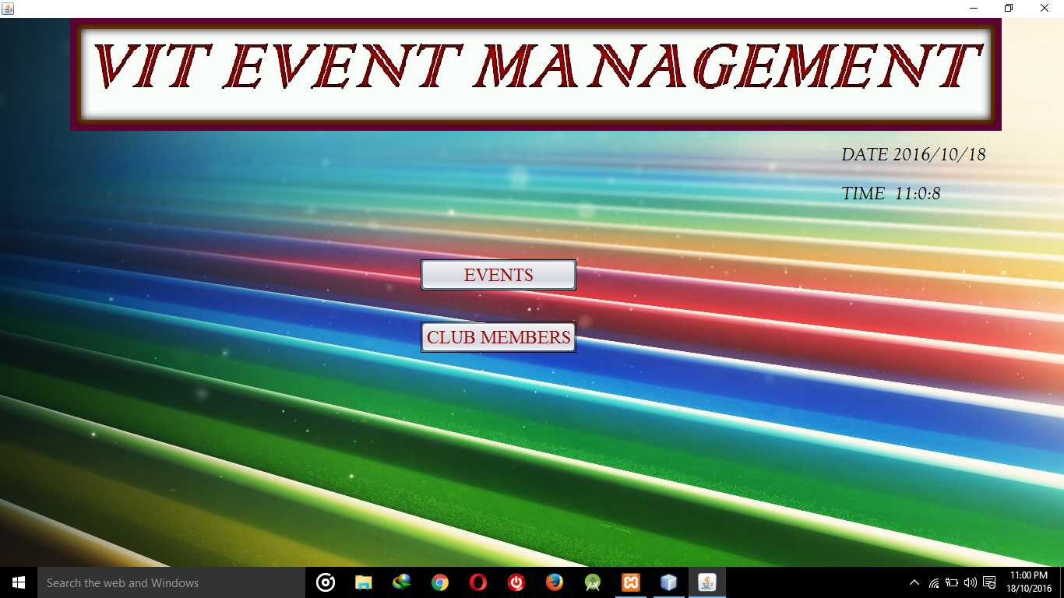

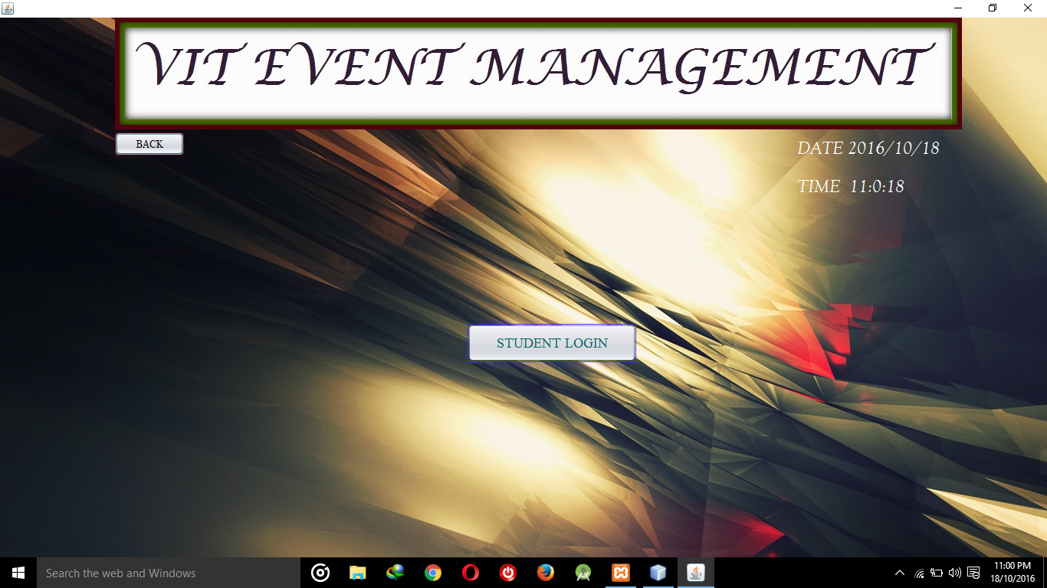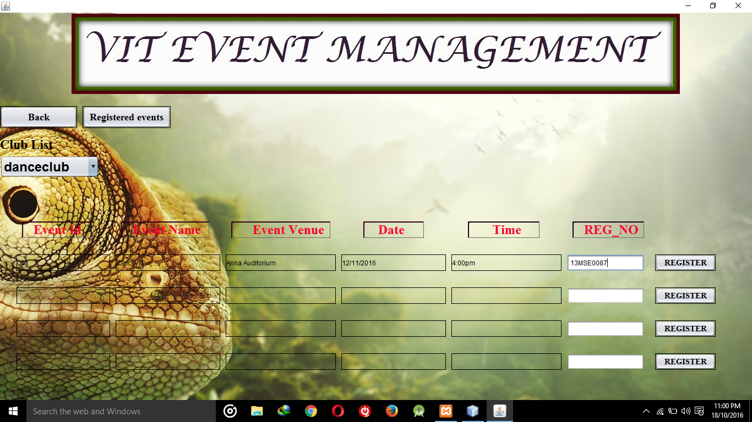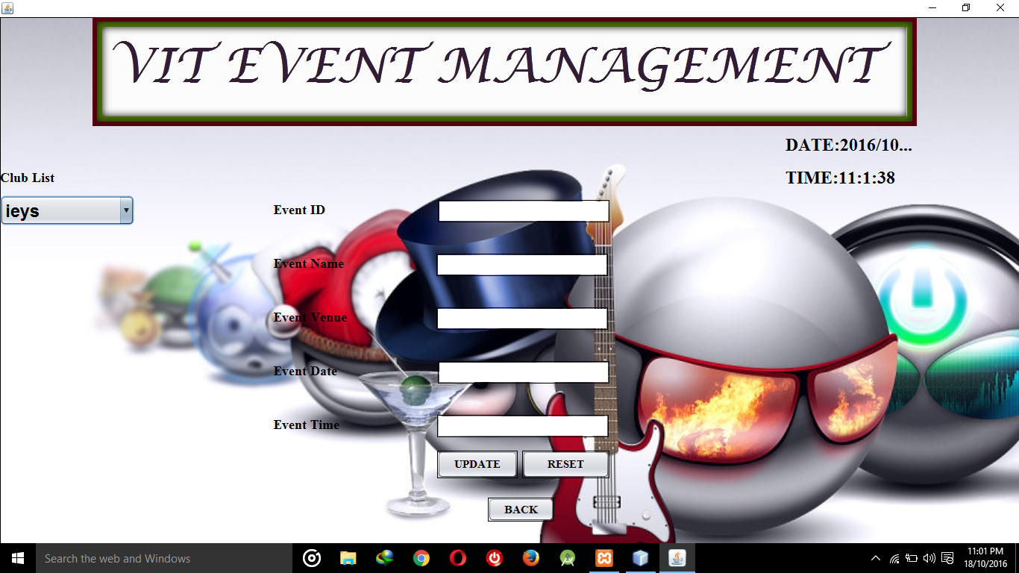

**7. References**

[1] ISSN: 2454-1362 Authors: Er. Fatima Anees, Ashraf Khan, Asjad Raza & Aftab Alam. Title: Scheduler application.

[2] ISSN: 2319-8753 Authors: Saipriya Sairam, Shruthi Suresh, Sanchana Hedge, Bushra Shaikh Title: Event Management an Android Application

[3] Electronic ISBN: 978-1-4799-5573-2 Authors: Phanuphong Hathaiwichian, Lapas Siriwittayacharoen, Apinat Wongwachirawanich, Chaiyong Ragkhitwetsagul. Title: Android application for event management and information propagation.